# WMS Active

POS is for card payments

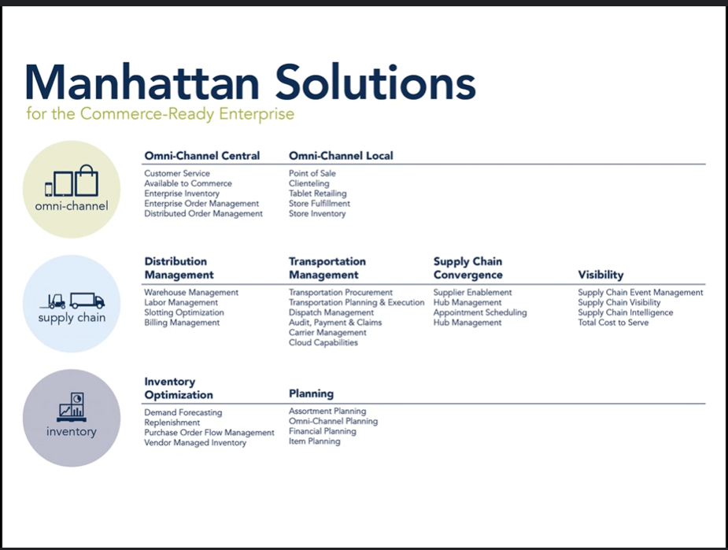

Slotting for warehouse management, depending on the warehouse size

SCI supply chain intelligence for reporting tool

JDA new version is BlueYander

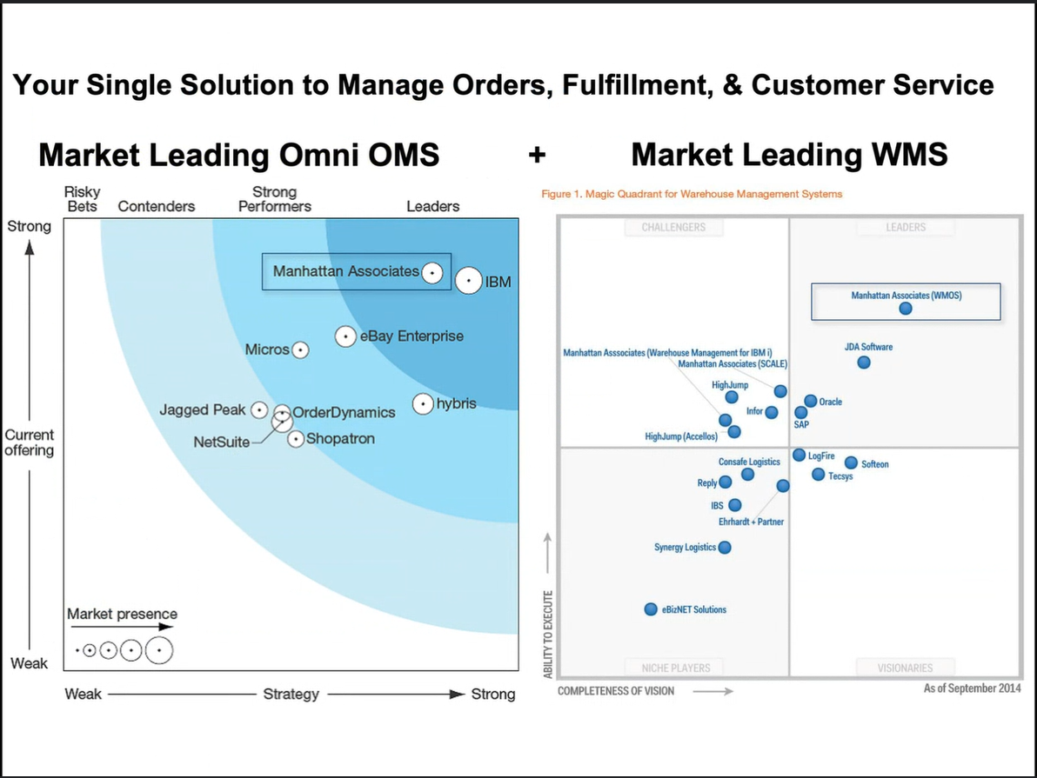

Before 2000 WMi

2001 to 2010 pk version

2011 to 2021 Manahattan Version (scpp version)

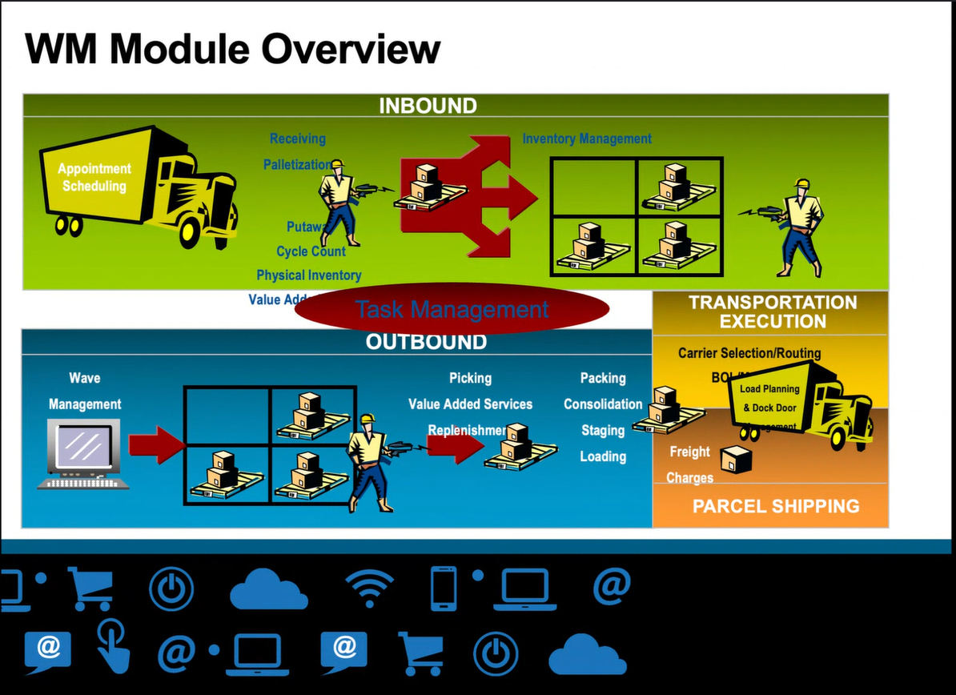

## Inbound

Pre receiving

Receiving

Putaway

## Outbound

Wave Management

It runs on c++.

In Active we have stream which replaces Waves.

On main page I get all the information/matrix.

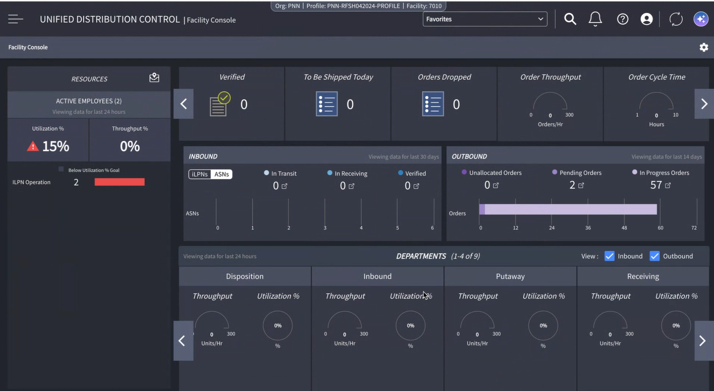

## Main changes for Active

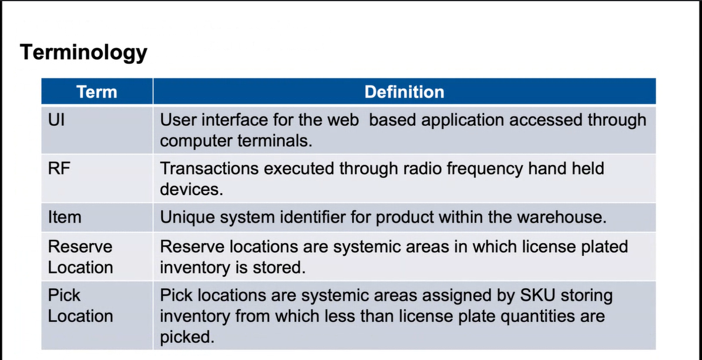

RF Menu 🡪 WM Mobile

Scpp version 🡪 2 types of locations 🡪 Reserve location/Pick location which replaced by storage location, we can identify the locations using storage UOM

UNIT 🡪 LPN/Pallets

UNIT 🡪 Active location

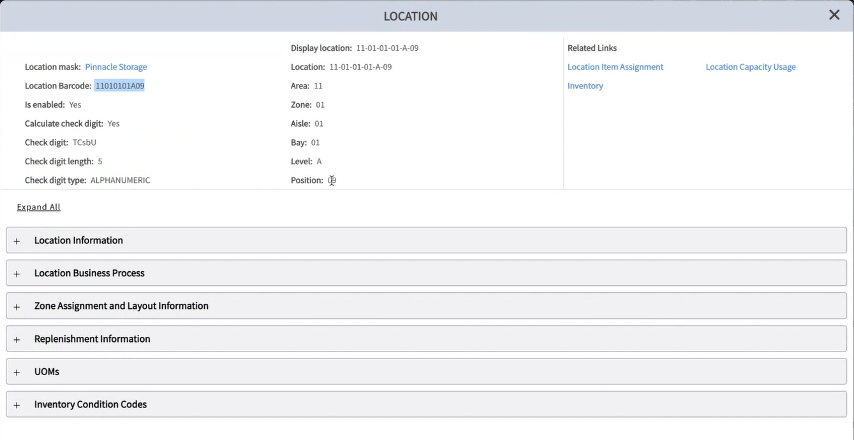

Location mask is a separate UI.

Item dedication type to SKU dedication type.

SKU 🡪 Stock Keeping Unit

Temporary 🡪We can use for any item which means dynamic usage.

Permanent 🡪

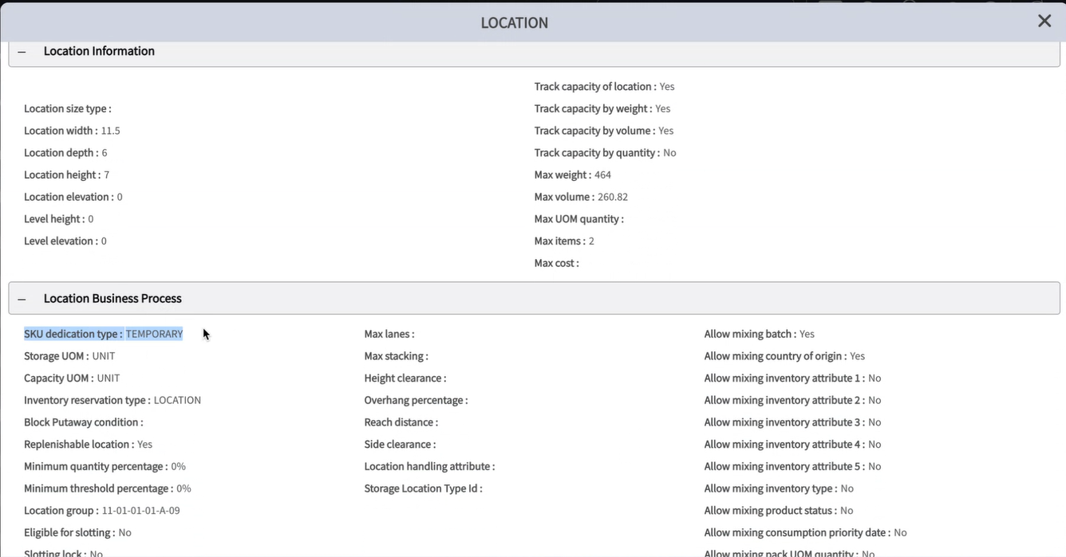

Location Creation

1. Export/Import Data Loader
2. API

Master Location:

Storage data 🡪 location master

ITEMS

Product class which is equivalent to putaway type in scpp which categorize the item types.

Questions:

Location Inventory/ Item inventory

**Advantages of ASN**

* Advanced visibility of inbound shipments
* Quick reconciliation of actual vs expected
* Improved resource management
* Improved outbound planning

Wave and Stream Run Process

Last updated:  01/02/2025

The Wave UI can be used to view the details of Order Planning Run Strategy. Primary card has the data from Order Planning Run Strategy Entity and the expanded card has the data displayed from Order Planning Run Summary.

There are Separate UI's to shows the data for both Order Planning Mode - "Wave" and "Stream", but the action defined only works if the selected record is Wave and not for Stream.

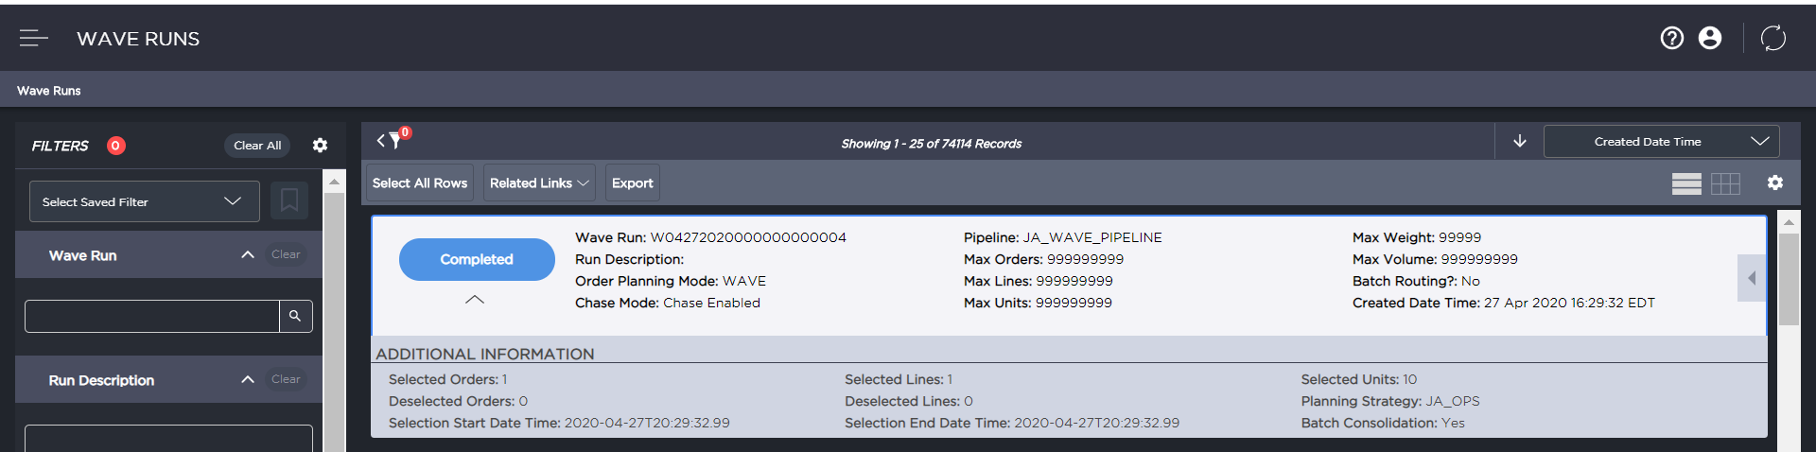

For the selected Order Planning Run Number, the related Links to below mentioned menu's are provided:

* Order Lines
* oLPNs
* Allocations
* Work Visibility
* Task Details
* Order Shortages
* Order Failures

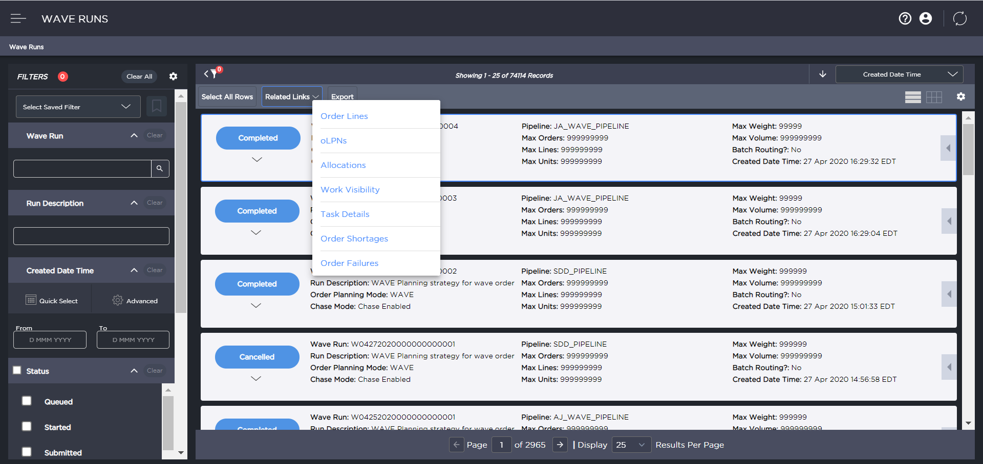

*Actions*

Wave Runs UI supports the following actions:

* Unplan
* Restart
* End Work
* Run Chase
* Order Exception
* Print Document
* Release Held Tasks
* Generate Tasks

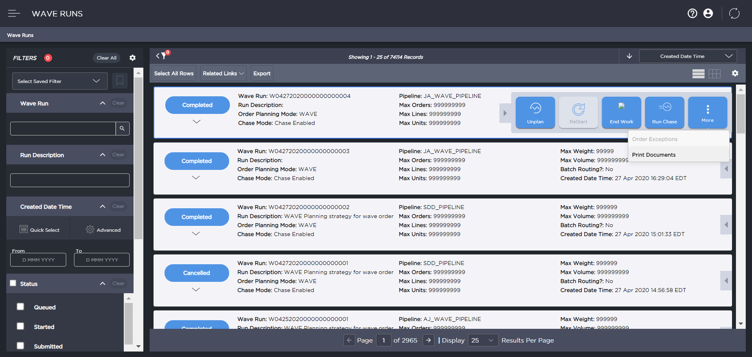

| Action | Description |
| --- | --- |
| Unplan | A waved order can be unplanned using this action. Orders can be unplanned until they are manifested. Even if one line is manifested, the whole order will not be eligible for undo |
| Restart | This action is used to Restart the Waves which is aborted at any point |
| End Work | This action is used for Cancelling/De-allocating the un-packed need. |
| Run Chase | This action is used to run the Chase for the Wave which has the Shortages |
| Order Exception | If any of the selected order line has “**lastStatusChangeDateTime OR updatedDateTime** > Current Date Time + “Age Timing used to Fail the orders struck as part the Run? (in minutes)” then log as “Order line %1 does not fall into the aged time frame to fail” (Skip these order lines as it would be a a sync process).  Need to fail the order lines and take it to Failed Status (orderline.Status). (If the order is in 2000, then take it to 2010 or if the order line is in 3000 then take it to 3010 (orderline.pipelineStatus)). Both status and pipelineStatus has to be updated. |
| Print Documents | This action is used to print the document for all the orders of the Order Planning Run based on the Batch Print Strategy selected by the user.    After selecting a batch print strategy, users have the option to further refine their selection by choosing specific batch print criteria for reprinting. This feature is particularly beneficial for scenarios where customers need to reprint documents for a specific area within a warehouse or based on certain rule conditions rather than reprinting for the entire batch print strategy.    Key Features:   * Criteria Selection: If no specific batch print criteria are selected, the solution will automatically run all active criteria associated with the chosen strategy. * Printer Location Selection: Users can choose a printer location during the reprinting process. It's crucial that all necessary printer type eligibility and zone printer cross-reference configurations are properly set up for the selected location. If any configurations are missing, the solution will not proceed with printing the documents. * Reprinting Process: During the reprinting process, the solution will evaluate the entire batch print strategy as selected by the user. It runs all the rules associated with the criteria under that strategy. However, it will only print for the specified oLPN/task based on the criteria the user has selected. * Comprehensive Rule Evaluation: The *All rule/criteria Run* option ensures that the solution identifies the same set of oLPNs/Tasks that were matched during the original wave run batch printing. |
| Release Held Tasks | This action is used to release any held tasks that are part of the order plan run. One or more task pool strategies that are configured with "Allowed for Manual wave task release" as true, can be used to select a subset of the held tasks for release. |
| Generate Task | This action is used to manually trigger the task generation process in a direct task creation exception scenario. Task generation can be triggered by selecting one of the four options available in the drop-down on the pop-up screen.   * Force a template and create tasks: This option allows the users to manually select a Picking Task Release Template and/or Replenishment Task Template and assign it to all the failed allocations part of the order planning run ID that has failed the template assignment process. Once the manual assignment is complete, the solution triggers the task creation process. * Reassign template and create tasks: This option allows the users to trigger the template reassignment process, system re-evaluates the failed allocations based on the predefined rules and assigns the appropriate templates. After the template reassignment process is complete, task generation process is triggered. * Reassign template, force the remaining and create tasks: This option triggers the template reassignment process, and if there are still allocations that remain in failed status after assignment, system will force-assign the Picking Task Release Template and/or Replenishment Task template selected from the drop-down for the remaining failed allocations. Once all the assignments are complete, task generation process is triggered. * Ignore failed and release the eligible allocations: This option allows the users to ignore the failed allocations and proceed with releasing the eligible allocations within the wave. The allocations in “Template Assignment Failed” status will not be assigned with a template or considered for task creation.   The manual assignment or reassignment of templates is only for the allocations that have failed template assignment and will not override if a template is already assigned. |

Wave Chart

Last updated:  11/08/2024

* [Wave Chart Sections](https://scexecution.helpdocsonline.com/wave_chart$wave-chart-sections)
  + [Summary Banner](https://scexecution.helpdocsonline.com/wave_chart$summary-banner)
  + [Permissions](https://scexecution.helpdocsonline.com/wave_chart$permissions)
  + [Actions](https://scexecution.helpdocsonline.com/wave_chart$actions)
  + [Charts](https://scexecution.helpdocsonline.com/wave_chart$charts)
* [Toggles](https://scexecution.helpdocsonline.com/wave_chart$toggles)

The **Wave Chart** page enables you to view the progress of waves that are run in the warehouse. You can track the progress of tasks that are associated with a wave, navigate to various department charts to monitor work at department level, and make operational decisions based on the information received.

**Note:** The UI has features such as filters, sort, and display options for quicker and better access to information. For more information, refer to [Common Functions](https://scexecution.helpdocsonline.com/common-functions).

This page represents wave status with a distinct legend for visual differentiation; clicking the wave bar opens a fly-out that contains more information on the selected wave.

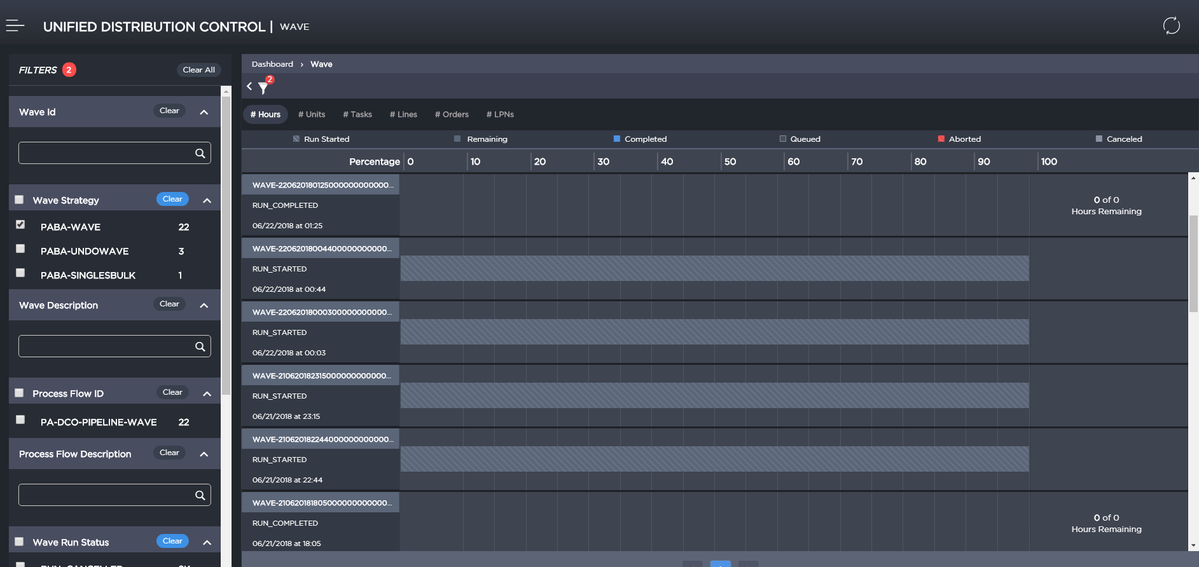

Wave Chart Sections

**Summary Banner**

The summary panel displays the overall status of the warehouse. The metrics are predefined and include:

* **Total Tasks** - Displays count of all uncanceled tasks for all waves at the facility level
* **Tasks** - Displays count of open tasks (pending completion) for all waves at facility level
* **Total Hours** - Displays the sum of estimated time for all tasks associated with all waves at the facility level.   
  When the user selects the **Hours** tab, the ETC is displayed on the Wave chart and the flyout.  
  ETC (Date and time) is calculated as Current time + Remaining hours

**Note**: ETC is not shown when the remaining hours are zero.

* **Remaining Hours**- Displays the sum of remaining hours (estimated - actual) for all tasks associated with all waves at the facility level

**Permissions**

To perform actions on the tasks page, you must have the following permissions:

| Permission Name | Description |
| --- | --- |
| View UDC Visibility | It allows you to view the Wave list UI |
| Maintain Waves | It allows users to perform all the actions on the Wave List UI |

**Actions**

The following actions can be performed on the current wave. The actions are context sensitive and are displayed based on the current wave's eligibility for the action.

* **Restart Wave** - Allows you to restart the wave. Applicable only for waves in 'Run Aborted' status.
* **Unplan Wave** - Allows you to undo all updates that were done as part of the current wave. You can unplan the wave for all wave statuses except 'Run Started'.
* **Navigation to Tasks List page** - Opens the Tasks List UI where tasks for the current wave are pre-filtered. Displayed only for waves in Run Completed/Canceled status.
* **Navigation to Work Visibility page**- Opens the Work Visibility UI where work records for the current wave are pre-filtered. Displayed only for waves in Run Completed/Canceled status.
* **Navigation to Orders  page**- Opens Orders UI where order records for the current wave are pre-filtered. Displayed only for waves in Run Completed/Canceled status.
* **Navigation to Order Lines  page**- Opens Order Lines UI where order line records for the current wave are pre-filtered. Displayed only for waves in Run Completed/Canceled status.
* **Navigation to oLPNs  page**- Opens Orders UI where LPN records for the current wave are pre-filtered. Displayed only for waves in Run Completed/Canceled status.
* **Chase Wave** - Used to trigger chase run for a shortage in a wave, eligible shortage order lines are processed. It navigates to the Order Planning Strategy UI to select a strategy to use for chasing waves.

**Note**: Displayed only for waves in 'Run Completed' status.

**Charts**

Every filtered wave is represented as a distinct card with a progress bar against it. This forms the Y-axis for the wave chart. Click the wave card or the progress bar to open the wave details fly-out.

**Note**: To populate data in Wave Charts, do the following:

* Set the *Disabled* flag to *No* to enable the OrderPlanningRunStrategySchedule job schedule. See [DC Order Scheduler](https://scexecution.helpdocsonline.com/dc-order-scheduler).
* Set the *Stop sending labor estimates* parameter to **No** on the Work Release Parameters screen.



The wave card contains the following information:

* **Wave ID** – Order planning run ID of the wave run
* **Wave Status** - Current status of the wave
* **Wave Run Date and Time** - Wave start date and time
* **Ahead/ Behind** - When Completed Hours By Planned < Completed Hours -  then the difference shows up as Behind with Completed Hours By Planned - Completed Hours

                                      When Completed Hours By Planned > Completed Hours -  then the difference shows up as Ahead between Completed Hours By Planned - Completed Hours

Completed Hours by Planned - Sum(Estimated Minutes)/60 where Labor Estimate Status = 8500 Grouped by Wave Number

Open Hours - Sum(Estimated Minutes)/60 where Labor Estimate Status < 8500 Grouped by Wave Number

Completed Hours - Sum(Actual Minutes)/60 Grouped by Wave Number

**Note**: Wave cards are sorted in descending order of wave run date and time. For example, if the chart is being viewed in 'Hours' UOM and the wave had 100 hours worth of work out of which 20 hours worth of work had been completed, then it would display as '80 of 100 hours remaining'.

Toggles

Toggles are provided right above the charts to allow you to change X-axis value of the graph. For every chosen UOM, data is represented as a percentage.

* **Hours**: Data is represented in terms of estimated and actual time (hours).
* **Units**: Data is represented in units that are allocated/ picked/ packed for a given wave.
* **Handling Units**: Displays the remaining handling units out of total units.
* **Order**: Data is represented as the count of uncanceled orders on a given wave.
* **Tasks**: Data is represented as the count of uncanceled tasks on a given wave.
* **Lines** : Data is represented as the count of allocations on a given wave.
* **LPNs** : Data is represented as the count of LPNs from all orders on the wave.

The following table describes the fields on this page:

| Field | Description |
| --- | --- |
| **Summary panel** | |
| Total Tasks Remaining | Represents the count of tasks that are open. This is represented in X/ Y format and also plotted on a donut chart for visualization. |
| Total Units Remaining | Represents the sum of units on all tasks that are open. This is represented in X/Y format and also plotted on a donut chart for visualization. |
| Total Hours Remaining | Represents time remaining (in hours) for the tasks to be completed. This is represented in X/Y format and also plotted on a donut chart for visualization. |
| Total LPNs Remaining | Represents the sum of LPNs that are not completed. This is represented in X/Y format and also plotted on a donut chart for visualization. |
| Total Orders Remaining | Represents the count of Orders that are not completed. This is represented in X/Y format and also plotted on a donut chart for visualization. |
| Total Lines Remaining | Represents the count of lines that are not completed. This is represented in X/Y format and also plotted on a donut chart for visualization. |
| **Department card panel** | |
| Department | Indicates the department associated with the wave task. Clicking on the department name renders the department chart view page. |
| Tasks | Shows Total Tasks, Completed Tasks and Remaining Tasks in the given department for the selected wave. |
| Units | the total quantity, Completed Quantity and Remaining Quantity on all tasks in the given department for the selected wave. |
| Orders | Shows Total Orders, Completed Orders and Remaining Orders associated with the tasks in the given department for the selected wave. |
| Lines | Shows Total Lines, Completed Lines and Remaining Lines associated with the tasks in the given department for the selected wave. |
| LPNs | Shows Total LPNs, Completed LPNs and Remaining LPNs associated with the tasks in the given department for the selected wave. |
| Hours | Shows total Total Hours, Completed Hours and Remaining Hours for all tasks in the given department for the selected wave. Also represents Ahead-Behind times to indicate lead-lag in work execution times. |

The View Departments link navigates the user to the Department Chart which displays all the Departments that have work associated with the wave.

